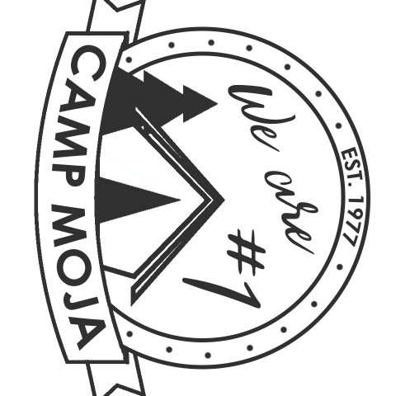
2019 NEW COUNSELOR PACKET
Previously Approved Community of Christ (CofC) Youth Workers
Camp Moja – Lake Doniphan – June 9-14

We are excited you’re applying to volunteer with Camp Moja this year!

There are four steps required to become a new counselor:
- complete the youth worker application and interview;
- complete a phone interview with one of the directors;
- complete the online Moja registration;
- attend training.

Since you have been previously trained as a CofC youth worker, please email the information below to CampMoja@gmail.com:
- name;
- phone number and best times to call;
- email address;
- how you heard about Camp Moja;
- which CofC mission center you completed your youth worker certification through and in what year.

Once this information has been received, you will be set up with a phone interview with a director. Once this is complete and you commit to attend camp, you will go to the registration form on CampMoja.org. (Please note, this will not be available until March.)

NEW COUNSELOR TRAINING
As a new counselor, you will be expected to attend training the afternoon of Sunday, June 9. More information will become available at a later date regarding the training, however, the current start time is scheduled for 2 p.m. that day.

If you have any questions please email CampMoja@gmail.com.

